Use this info to answer number 1
This chart shows total energy consumption, measured in millions of tons of oil equivalents, for seven different countries.
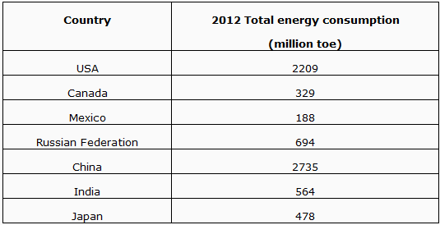

1)In order to compare the energy use per capita of the countries, what calculation must be done?

Use this graph to answer number 2
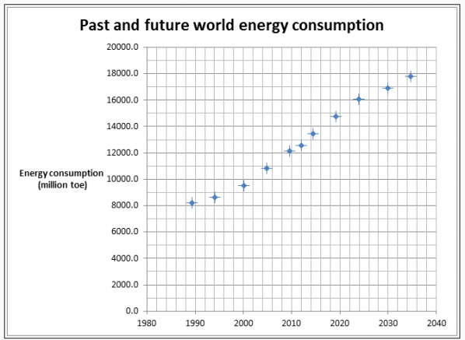

2) The world population is 7.23 billion (April 2014) and is predicted to be 8.3 billion in 2030. Compare the percent increase in population to the percent increase in world energy consumption (show your calculations). Which shows a higher rate of increase? What can you conclude from this?

Use this info and graph to answer number 3 and 4
This US example shows the change in the output from two hydroelectric power stations in two different states over a 20 year time period.
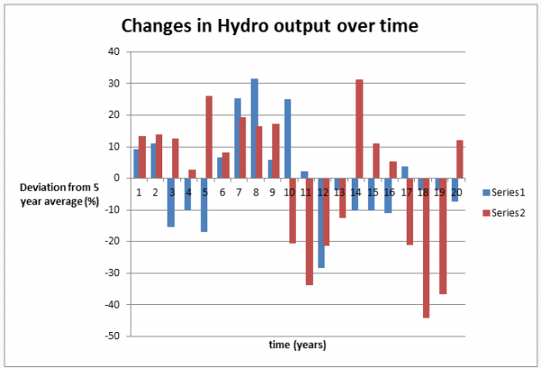

3) What conclusion can be drawn from this graph?

4) How might this data be used to decide what proportion of total electric power should come from hydroelectricity in this country?

5) The common name for ethyne is acetylene. Acetylene torches are used in welding metals. Find the molar heat of combustion of ethyne. Show your work including any formulas, substitutions, and write your answer rounded to the correct number of significant digits and with the appropriate unit. The balanced equation for this reaction is

C2H2(g) + 5/2 O2(g) → 2 CO2(g) + H2O(g)

6) Estimates of world oil reserves currently run at fifty to sixty years. Explain how this number may change during the next 20 years.

7) Suppose that a group of students found some data on world oil reserves and energy consumption. Upon closer inspection, the students found that the data they found differed from student to student. Suggest two possible reasons for the discrepancies.

Use these pics and info to answer number 8
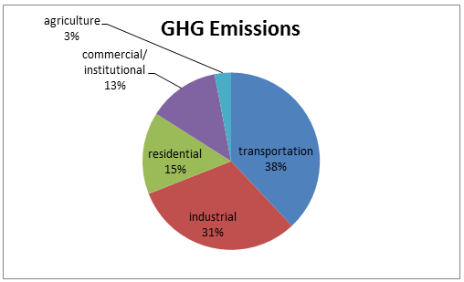
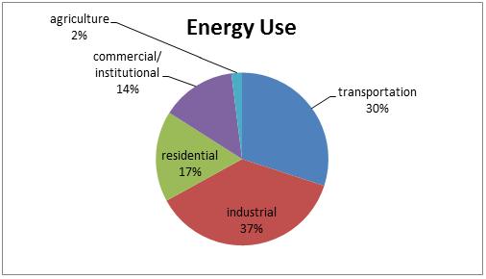
These graphs show energy use and greenhouse gas (CO2 emissions) in Canada in 2011. Just over two thirds of energy use and CO2 emissions come from transportation and industry but the proportions of each are different.

8) What can you conclude about the energy processes involved in the two sectors and what might this suggest about government regulations?

9) Explain what thermal pollution is and relate your explanation to a coal fired plant.

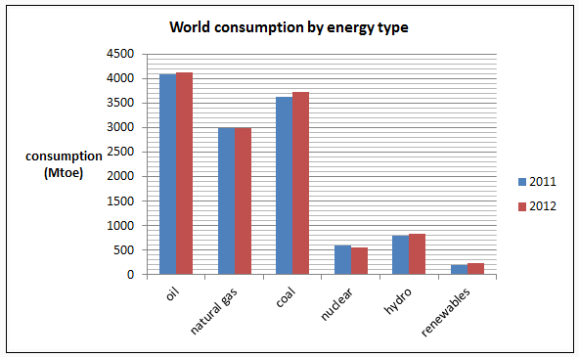

10) Energy values are in million tonnes of oil equivalents (Mtoe). What percentage of the total energy use in 2012 was from fossil fuels? Show your calculations and round your answer to the nearest percent.

11) Explain how the use of biomass lowers greenhouse emissions compared to the use of fossil fuels.

12) A 1000 MW nuclear power plant will produce 3.15 ×1016 J of energy in a year. What mass must be converted to energy to do this? Show your work including the formula, substitution, and answer, rounded to the correct number of significant digits and with the appropriate unit.

13) Find the energy released or absorbed when one mole of helium-4 is produced in this reaction. Show your work including any formulas use, substitutions, and record your answer to the correct number of significant digits including the appropriate unit. Also include whether the reaction released or absorbed energy.
³₂He + ³₁H → ⁴₂He + ¹₁H + ¹₀n

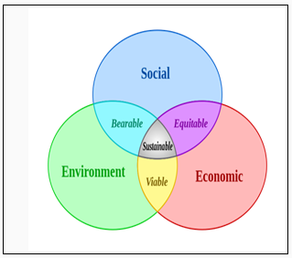
14) Sustainable development is a difficult balance to achieve. Suppose we decide to reduce production in the Alberta Oilsands.
a) What effect might this have on the environment? (2 marks)

b) What effect might this have on the people of Alberta? (2 marks)

15) To reach sustainability with a larger world population we must do more with less. For each of the following strategies that promote sustainability within a city, explain how each will reduce greenhouse gas emissions.
Don’t allow cars in the centres of the cities.
Plant gardens in all empty lots.
Cover all roofs with solar cells.
Plant trees in every yard.

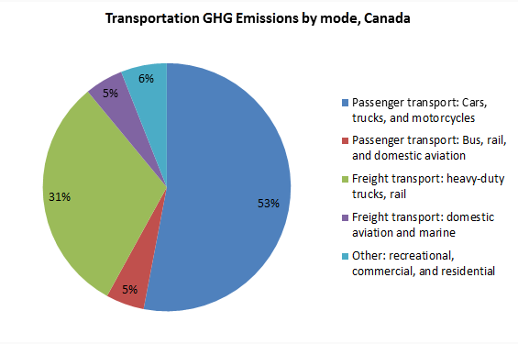
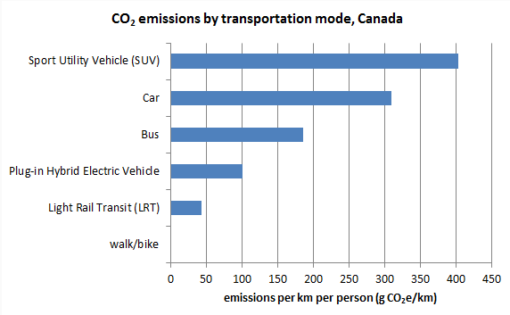
16) What forms of transportation account for the majority of greenhouse gas (GHG) emissions in Canada?

17) A natural gas based power plant is rated at 150 MW. If the input energy to this power plant is 420 MW the efficiency of the plant is ___%.

Show all your work. Round and record your answer to the nearest percent.

18) A 1000 MW thermal power plant is 38% efficient. A team of engineers is tasked with raising the efficiency of this plant to 40%. By how much must they reduce the input power?
Show your work including any formulas, substitutions, and your answer rounded to the correct number of significant digits and with the correct unit.

19) Many Canadian power plants run slightly more efficiently in winter than in summer. Explain why this should be expected.

Use the following graphs to answer question number 20 and 21
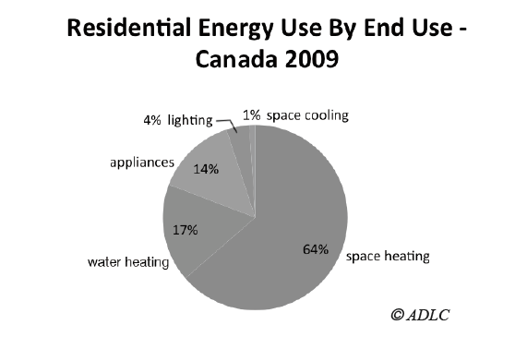

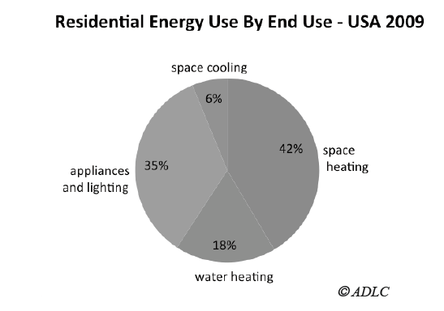
20) Many Canadian power plants run slightly more efficiently in winter than in summer. Explain why this should be expected.

21) Compare the use of energy by Canadians and Americans in 2009. (Note that appliances and lighting are combined in the USA graph. What might explain the differences in space heating and space cooling?

22) Explain how biomass and biofuel projects can give us energy products that don’t use up valuable agricultural land.

23) You have seen that in order to replace fossil fuels with wind energy we would have to use enormous areas of land covered with wind turbines. Explain how we might be able to do this and still have space to move around.

